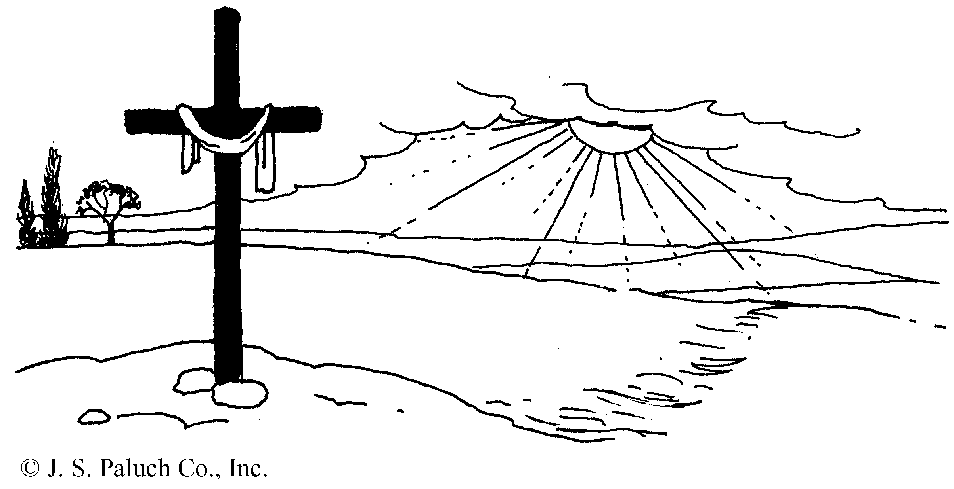

Armond Clay (Sonny) Jordan
August 5, 1934 – July 30, 2021
Clay Jordan died peacefully at home surrounded by his family and caregiver. He is survived by his wife, Kathi, his son, Adam (Alice) and granddaughters, Kaiya and Mika, his brother, Morris (Sylvia), and sisters-in-law, Raewyn Cummings, Carol Jordan, and Sue Cummings, brother-in law, Tim Cummings, and many nieces, nephews, and cousins.
Clay, a graduate of Ohio State University, became an art instructor in the Mt. Diablo Unified School District after doing graduate work at the now California College of the Arts. He taught for almost 25 years. Among the subjects he taught were glass blowing, sculpture, jewelry, and fine wood working. He was granted a sabbatical and was accepted into the Royal College of Art in London, where he studied sculptural glass blowing.
In retirement he became passionate about fine wood working and became a master craftsman, creating stunning furniture including tables, desks, bookcases, beds, chests, cabinets.
An avid traveler, Clay, his wife, and son traveled throughout North Africa, Europe, Asia, Mexico, Central, and South America, and Canada.
Clay was also an avid reader and preferred books on history. In his healthy years, he would average 1 to 2 books each week and then go looking for another book.
Atypical Parkinson’s Disease intruded into his retirement years, but he endured that struggle with amazing grit and grace and never complained. Clay maintained that grace until the very end.
As friends have shared, Clay was a good, kind, intelligent, and talented artist and friend, as well as a wonderful, compassionate husband and father. We will miss him so much. Life will not be the same without our beloved Clay Jordan.

Presiding: Fr. Ivan Tou, CSP
Guitar & Cantor: Rob Grant

A Celebration of the Life of

Armond Clay (Sonny) Jordan

Born into this Life – August 5, 1934
Born into Eternal Life – July 30, 2021

Funeral Mass
10:30am, August 11, 2021

Newman Hall – Holy Spirit Parish
2700 Dwight Way; Berkeley, CA 94704

The Introductory Rite

Greeting and Sprinkling with Holy Water

Gathering “Be Not Afraid”

Opening Prayer

THE LITURGY OF THE WORD

First Reading Ecclesiastes 3:1-11 Kaiya Jordan (granddaughter)
Thanks be to God.

Psalm Psalm 23
My Shepherd is the Lord, nothing indeed shall I want.

Second Reading Romans 8:14-23 Adam Jordan (son)
Thanks be to God.

Gospel Acclamation “Celtic Alleluia”
Gospel Matthew 5:1-12
Praise to you Lord, Jesus Christ.

Homily Fr. Ivan Tou, CSP
Prayers of the Faithful Rosemary Loughman (family friend)
Lord, hear our prayer.

THE LITURGY OF THE EUCHARIST

Gifts of the People “On Eagle’s Wings”

Preface Acclamation
Holy, holy, holy Lord God of hosts.
Heaven and Earth are full of your glory.
Hosanna in the highest
Blessed is he who comes in the name of the Lord.
Hosanna in the highest.

Memorial Acclamation
When we eat this Bread and drink this Cup,
we proclaim your Death, O Lord,
until you come again.

Great Amen
Amen.

The Communion Rite
Lord’s Prayer
Sign of Peace
Breaking of Bread
Lamb of God, you take away the sins of the world, have mercy on us.
Lamb of God, you take away the sins of the world, have mercy on us.
Lamb of God, you take away the sins of the world, grant us peace.
Communion Procession “Amazing Grace”
Post-Communion “Panis Angelicus”

The Concluding Rite
Eulogy Adam Jordan
Final Commendation
Song of Farewell “Song of Commendation”
Final Blessing
Recessional “You Raise Me Up”

